Fake News Detection with Machine Learning: A Comprehensive Survey
Shristi Singh¹, Prerna Rajora² and Sonali Rawat³
¹²³ Indira Gandhi Delhi Technical University For Women
¹shristi131btit24@igdtuw.ac.in
²prerna107btit24@igdtuw.ac.in
³sonali134btit24@igdtuw.ac.in
Abstract: A prominent issue at present is that entities from different sectors
struggle to find efficient and reliable method to detect fake news online. Misinformation seriously impacts society, especially in areas like politics and education. The proposed work addresses the issue of false news by developing a detection model based on multiple classification algorithms. The rapid spread of information and news through instant sharing has contributed to the exponential rise in its misrepresentation. We begin by addressing the consequences of fake news. Thereafter, we discuss the datasets utilized in previous findings along with their NLP (Natural Language Processing) techniques such as N-gram analysis, TF-IDF (Term Frequency-Inverse Document Frequency), word2vec, Data preprocessing, Tokenization, Normalization, Regex, Lemmatization, and Generalization. After analysing several studies on fake news detection, we have identified the most frequently used models, such as LSTM-RNN (Long Short-Term Memory - Recurrent Neural Network), Naïve Bayes Classifier, Support Vector Machine (SVM), Passive Aggressive Classifier, KNN (K-Nearest Neighbors), LSVM (Linear Support Vector Machine), LR (Logistic Regression), and Decision Tree. As evidenced, the SVM and Bi-directional LSTM-RNN (Long Short-Term Memory - Recurrent Neural Network) model achieved the highest accuracy of 100%, whereas the lowest accuracy, 47.2%, was observed with the KNN and SVM models when utilizing four-gram word features. The outcomes of this research helps to strengthen the efficiency of false news detection methods.

Keywords: Fake News, SVM (Support Vector Machine), LSTM (Long Short-Term Memory), word2vec, Naïve Bayes, TF-IDF(Term Frequency-Inverse Document Frequency)

Introduction
News has the potential to enlighten minds, inspire purpose, and build creative ideas through shared experiences. The digitization of news has surpassed traditional media, amplifying the spread of deceptive content. It has also facilitated non-journalists to share their opinions and perspectives publicly.
In today's digital era, social media serves as a powerful platform for the circulation of information, connecting people across the globe. Social media serves as a platform for creating and sharing information that operates through the Internet of Things (IoT). However, along with these benefits, social media has caused the hazardous development of a wide range of falsehoods, like malicious discussion, double-dealing, fabrications, fake news, and spam assessment, which diffuse quickly and widely in human culture.
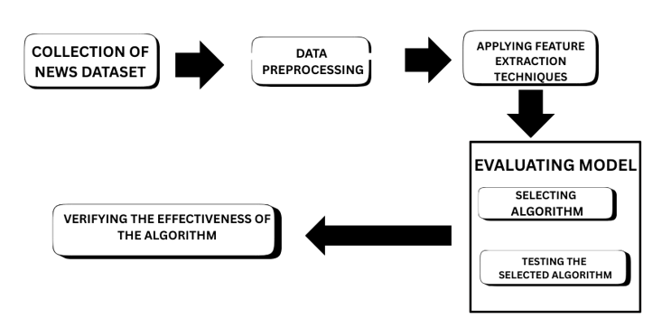
Figure 1: Common methodology behind detection of false news[1]
Researchers in the social sciences have analyzed false news from multiple angles that proposed a broad classification of various types of false news, such as those outlined by Parikh, Shivam B., Atrey, and Pradeep K.[2]. And this classification is summarized below.
Multimedia-based: Multimedia-based false news makes extensive use of graphical representations such as photoshopped images, videos, and/or a combination of both.
Client-based: Client-based leans heavily on a certain audience through fake accounts, targeting audiences of particular age groups, cultures, genders, etc.
Post-based: Post-based is most often observed on social media platforms. Posts can be an Instagram post, together with an pictures or video and a caption, a tweet, etc.
Network-based: Network-based news aims at certain members of a specific organization or communities that are connected in some way. This approach also applies to groups of friends on Facebook or mutually connected individuals on LinkedIn.
Style-based: The primary focus of style-based detection is how information is presented to readers. Since most fake news is not written by professional journalists, the writing style often displays significant variation.
The types of data in the news are mainly classified into four subtypes. These subtypes are a combination of other types.[2]
Text:
Text was initially studied through textual analysis, a branch that focuses on text as a system of communication. This field is not just concerned with individual sentences and words but also includes features like tone, grammar, and pragmatics, which enable effective communication analysis.
Multimedia:
Multimedia is a combination of different types of media, such as images, videos, audio, and graphics. And as they are highly visual, they easily catch the attention of viewers.
Hyperlinks or Embedded Content:
Hyperlinks allow users to connect to various external sources, helping to build accuracy by supporting the claims made in a news story. With the rise of social media, writers can now easily incorporate content from platforms such as Facebook, Twitter, YouTube, SoundCloud, and Instagram directly into their articles.
Sound-track:
Sound-track is an element of the interactive media group but also serves as a standalone medium for news. This category includes podcasts, broadcast networks, and radio services, which reach a wider audience to deliver the news.
A typically news article consist of three main components: a bold title, interactive media (such as images, videos, or texts), and the body (the main story content). People generally focus on the headline and multimedia, as they are comparatively more eye-catching than the body.
A few vivid examples of how headlines and multimedia can mislead readers are as follows:
Fake Headline: "Bill Gates Plans to Microchip Humans via Vaccines"
Truth: This false narrative claims that Bill Gates has planned to track people through vaccine-implanted chips. But in reality, the Gates Foundation funded vaccine record-keeping technologies and not microchips.
Source (https://www.bbc.com/news/52847648)

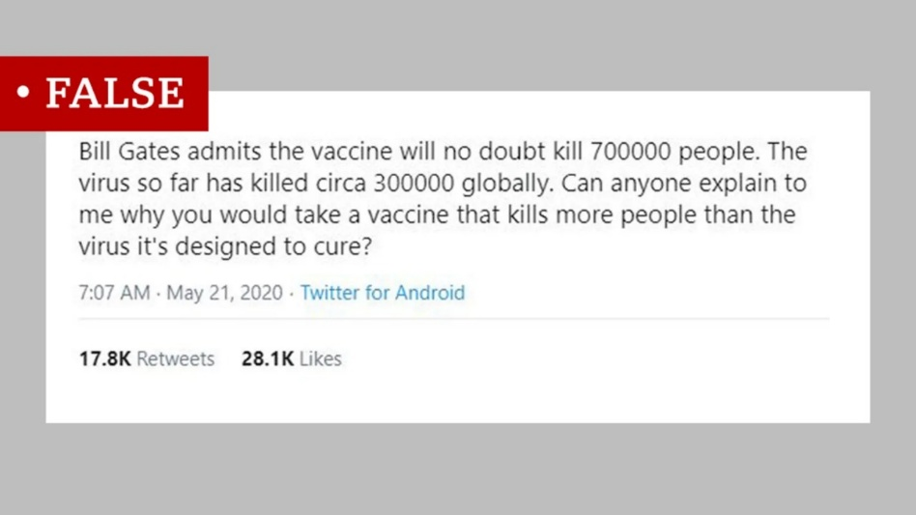
Figure 2 illustration: This is the made-up tweet that was circulated about Bill Gates.

The traditional machine learning approaches consist of naïve Bayes, SVM, logistic regression, and decision trees, out of which naïve Bayes showed the best accuracy rate, i.e., 96.08%[3].Whereas in the case of deep learning models such as CNN, RNN-LSTM, and BERT, RNN-LSTM excelled (Prachi et al. 2022).
Our survey provides the following key contributions:
- We delve into the trends in fake news research from 2017 to 2025 and emphasizing the necessity of adopting a broad outlook on the rise of false narratives
- We condense our review and outline potential developments for fake news research.
- Through our analysis, we highlight how authentic information can be distorted into fabricated news, using an example to show how this can deceive the public.

Table 1: Overview of Fake News Detection Techniques Highlighting Datasets, Methodology, Algorithms, Features of Extraction, Results, and Challenges.
REFERENCE | DATASET USED | METHODOLOGY | FEATURES OF EXTRACTION AND ALGORITHMS USED | RESULTS | ADVANTAGES | LIMITATION | FUTURE WORK
[3] | The Author extracted two datasets, namely "Getting Real about Fake News" and "All the news" from Kaggle | Text preprocessing, Encoding of the text, Extraction of the characteristics, Support vector machine: | Used TF-IDF of bag-of-words and n-grams as a feature extraction technique  The Support Vector Machine (SVM) model is used. | The methodology gave a recognition rate of 100 %. N-gram method gives a better result. SVM appears to be the most effective algorithm for false detection models as it has a higher accuracy rate. | The use of SVM results in high accuracy, including a 100% recognition rate | The dataset used is relatively small and lacks diversity | In the future, we can involve using a larger dataset and adapting the model to an online learning framework for continuous updates and automatic detection of new fake news.
[5] | The author and his team gathered a dataset by combining news articles from Reuters.com. | Data collection, preprocessing, feature extraction, Model Training and Classification, Performance Evaluation | The Linear Support Vector Machine (LSVM) model is used.  Term Frequency and Term Frequency-Inverted Document Frequency | DT got 89% accuracy, LSVM performed best at 92%, while KNN and SVM had the lowest at 47.2%. Using n-grams with LSVM gave 87% accuracy. | The model achieved a 92% accuracy using Linear SVM, which is among the best for traditional machine learning approaches. | The dataset is limited to the 2016 US election, which may not reflect current evolving patterns in fake news language. | The author could evaluate the model on several publicly available datasets, including the LIAR dataset
[6] | The author used two datasets from the open Machine Learning Repository accessible at Kaggle. | CNN, Vanilla RNN, Unidirectional LSTM-RNN, and Bi-directional LSTM-RNN | Features of Extraction: word2vec, GloVe[16], or FastTex TF-IDF.  Adaptive learning rate algorithms is selected to train the models AdaGrad, RMSProp, and  Adam. | For dataset 2, Bi-directional LSTM-RNN gives 100% accuracy, and for the first one, it gives 99.92% accuracy. | If the words from heading and article are found to have similar meaning then the news is believed to be more trustworthy. | The performance of the model depends on the author's information. The model is computationally expensive. | Future experiments must explore how deep learning with attention can enhance automatic news credibility analysis.
[7] | The author used two datasets, WEIBO and PHEME. | 1. General Framework 2.Multimodal Feature Extraction 3. Multimodal Feature Fusion  Feature extraction: 1. GRU (Gated Recurrent Unit) 2.Long Short-Term Memory (LSTM) 3. Recurrent Neural Networks (RNNs) | The author proposed MUSE, a fake news detection model using NAS to boost generalization. It explores GRU, LSTM, and RNN architectures. | MUSE demonstrates strong flexibility to the quality of data and surpasses all baseline models in terms of accuracy and F1 score. | By incorporating NAS, MUSE could dynamically adjust the architecture of the model according to the data, enhancing its effectiveness. The study elaborates the effectiveness of MUSE in detecting fake news. | While MUSE adapts to missing modalities, its performance in scenarios with highly imbalanced or incomplete multimodal data is not extensively tested. | In the future, the author plans to explore the use of MUSE in resource-constrained scenarios.
[8] | The author used the Chinese dataset Weibo21 and the English dataset GossipCop | 1. Inter-adversary Prompting  2. Self-reflection Prompting | LLM-GAN  The author has not used any explicit feature extraction method | LLM-GAN outperforms all baselines (i.e., BERT, EANN, Publisher-Emo, ENDEF, SuperICL, and ARG) across all datasets and evaluation metrics. | LLM-GAN has proved to be an effective model to inspect the content of the news and gives explanations that are correct, logical, and human-readable detection explanations, demonstrating its explainability. | The framework heavily relies on LLMs, which can be resource-intensive and costly to deploy in practice | Adding image and video analysis capabilities to address fake news that involves multimedia content.
[9] | The dataset consist of 23000 fake news articles and 21000 true news articles | The dataset has been divided into two portions training and testing. And by using Naive Bayes method the false news is detected correctly. | Naive byes  TF-IDF (Term Frequency-Inverse Document Frequency), Bag-of-Words, CountVectorizer. | The model achieved nearly equal accuracy for detecting both real and fake news | The model received a high accuracy of 0.97 in detecting real and fake news. | The system is not adaptive as it doesn’t update its knowledge dynamically with new data. | The performance of the model could be enhanced by adding more training data, as a larger dataset leads to better accuracy
[10] | 23,593 tweets were gathered by the author. Out of which 402 tweets were selected, which included 202 fake news and 200 true news tweets. | The methodology adopted by the author is k-fold cross-validation. | LR, NNET, CART, SVM, and  RF  TF-IDF, Naive Bayes | The CART and NNET models had the best performance at 94.6%, while LR and SVM had the lowest at 91.3%. | Redundancy and poor performing models can we avoided to identify the best combination of models and hyperparameters. | This lacks an AI (XAI) method that provides transparent and interpretable results. | For the future research, the study plans to gather fake news data from more platforms to reduce differences between social media sites and make the results more general. Also, this study only used English-language messages, so it didn’t account for different cultures or languages.
[11] | The author used two datasets, Weibo-21 and MCFEND. | The model used in it is BERT AND RoBERT, which focus on the textual content of news. | Perception and Observation, Reflection and Analysis, Reasoning and Decision  The author used a cross-attention mechanism applied between textual and visual features.  The post \( p \) has multi-modal features \( h_p = \{h^A_p, h^V_p, h^C_p, h^F_p\} \), where \( h^A_p \) and \( h^C_p \) come from BERT. | By using the CMFNThinker, the model gets improved by at least 11.3% on MCFEND-Group 1 and 13.2% on MCFEND-Group 2. | As the CMFNThinker model helps to detect truthfulness by analyzing news content, past cases, and multi-model data, it increases the efficiency of the experiment. | This model considers social context as background information without even distinguishing which leads to misleading in detection. | By adding similar news posts, there is a performance drop in the model. So, this should be considered in the future.
[12] | Fake News Dataset (FND) with the ISOT Fake News Dataset (ISOT FND) from Kaggle. | Structured approach that involves gathering data, preprocessing it, training models, assessing their performance, and exploring dynamic strategies for future work. | Machine learning techniques- Support Vector Machine (SVM) and Logistic Regression (LR)  Include Word Embeddings and TF-IDF vectorization. | SVM showed better performance than LR in terms of accuracy, precision, F1 score and recall in detecting fake news. | Evaluation through accuracy, precision, recall, and F1-score offered a well-rounded understanding of model effectiveness. | The author only compared SVM and LR didn't include more advanced or recent models like Random Forests, XGBoost, | The authors aim to design a methodology for continuously updating the fake news detection model with real-time data, enhancing its ability to adapt to changing patterns in misinformation. The authors will also integrate drift detection mechanisms into the update process.
[13] | The authors have gathered 37106 false news and 35028 true news from WELFake and 10370 false news and 10350 true news from Kaggle | Data Collection and Pre-processing, Data Preparation, Feature Extraction, Sequential Modeling & Classification | The CSRN model is used by the author. CAEN (BERT and FinText) | The FFN detection approach  Surpassed Zhi et al. [17] work. | The combination of BERT and FinText in CAEN allows the model to capture both linguistic and financial domain-specific context, which is necessary for financial fake news. | The model is relatively complex, involving multiple stages. This could lead to longer training times and deployment difficulty. | For future research works, a new annotated FFN dataset should be created.
The summarized comparative analysis in the table given above highlights the progressing landscape of fake news detection datasets, methodologies, and feature extraction techniques.
Over the last years, various researchers have analyzed fake news detection using a variety of datasets.[3]Employed two datasets from Kaggle, namely "Getting Real about Fake News" for fake news and "All the News" for real news.[5] Manually curated a dataset by gathering multiple news articles from Reuters.com. Additionally, they used the "Horne and Adali" dataset from Kaggle to test the model they implemented[6]Adopted datasets from the Kaggle machine learning repository.[14] Executed their work using "WEIBO" and "PHEME" datasets.[8]
Carried out their research using the Chinese dataset "Weibo21" and the English dataset "GossipCop".(Aji et al., 2021) collected a large dataset comprising 23000 fake news datasets and 21000 true news datasets. (Park & Chai, 2023) gathered 23,592 tweets and selected 402 tweets out of which 202 were fake and 200 were true. (Tian et al., 2025) relied on two datasets, "Weibo-21" and "MCFEND," for their multimodal approach. (Jadhav et al., 2024) worked with "Fake News Dataset (FND)" along with "ISOT Fake News Dataset", both sourced from Kaggle.
[13]Employed the WELFake dataset, consisting of over 37,000 fake and 35,000 real news items, and an additional Fake News dataset from Kaggle.

These researchers employed numerous feature extraction techniques, models, and followed a systematic methodology for the detection of fake news. Traditional feature extraction techniques such as Term Frequency (TF), TF-IDF, Bag-of-Words, CountVectorizer, and n-grams were extensively used [4, 6]. More high-level approaches utilized word embeddings like Word2Vec, GloVe, and FastText[6]while deep learning-based models integrated multimodal feature extraction using BERT, RoBERTa, GRU, LSTM, and cross-attention mechanisms to aggregate textual and visual data [15, 16]. Talking about the methodology, the majority of the studies followed a common and systematic process of data collection, preprocessing, feature extraction, model training, and evaluation, with some incorporating cross-validation and custom sequential modeling frameworks such as CSRN and CAEN [17]. Some authors used traditional machine learning classifiers such as Naive Bayes, Logistic Regression, Decision Trees, Random Forests, and Support Vector Machines (SVM), whereas others used deep learning models like CNN, RNN, LSTM, and Bi-LSTM. Recent advancements used novel frameworks like MUSE, LLM-GAN, etc. These approaches demonstrate how the researchers have progressed from conventional classifiers to more adaptable systems of handling complex and multimodal data.

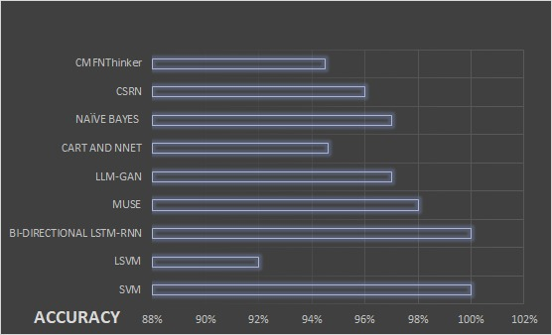

Figure 3: Comparative analysis of model accuracies in fake news detection across ten implementation papers.[18]

Survey of Datasets and Models in False News Detection

After going through several survey and implementation research papers, there are various factors that are necessary for a fake detection model:
Let's see what they are:
Firstly, for any research, the basic thing is the source or the dataset that we are going to use. There are many reliable sources that can be used to do so. Twitter , Liar, Reuters, and Fever are some of the sources that can be used. [19] worked on the Covid-19 Fake News Dataset, which has samples of 8560 tweets.[20] trained a dataset from Kaggle that has over 1500 entries, and [21] also used the same source.[22] conducted research on a dataset of 20,800 entries that includes 2077 true news and 2083 fake news. [23] composed research on a dataset from Kaggle with 23,481 fake news and 21,417 true news. [24] prepared a research paper using datasets from LIAR , FEVER, and FAKENEWWSNET. [25] collaborated on a research initiative by using a real-world database from Reuters.

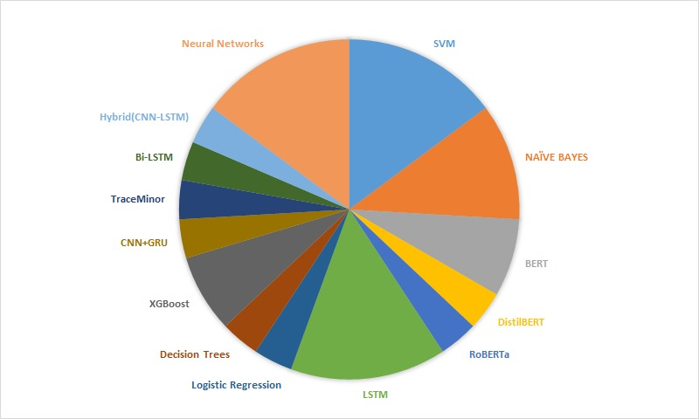
Figure 4:Distribution of all the models used across ten surveyed papers on fake news detection[18]
Secondly, for research work, it's necessary to work with a dataset that is well-trained, and for that, you need a perfect, reliable model. Some of the models that the author used frequently are
SVM, LSTM, Naive Bayes, BERT, and CNN.[26] The goal of this paper is to test three different BERT base pre-trained transform learning models (BERT, DistilBERT, and RoBERTa) on an English COVID-19 fake news dataset to detect the fake and true news separately. While in [25] collaborated with the same BERT Model along with TF-IDF-DNN, BoW, and word2vec. [21]contributed to the paper by working with the Naive Bayes algorithm.[23] trained the model with Decision Trees and XGBoost, which improved the efficiency of the dataset. LSTM Model is also the most commonly used and efficient model. [20] and [27] formulated with LSTM model for training on their dataset.

Results
The studies reviewed showcase the different approaches that can be used for fake news detection through machine learning and deep learning models. These works feature both the strengths and limitations of current models. The reviewed studies demonstrate several advantages in the field of fake news detection. The majority of the models, whether it is traditional such as SVM, Naive Bayes, or deep learning approaches such as LSTM, BERT, display high accuracy, often exceeding 90%, indicating their effectiveness. In particular, the deep learning models show enhanced performance in capturing complex patterns in data. Some advanced models, such as LLM-GAN and CMFNThinker, offer additional benefits such as multimodal analysis, adaptability, and explainable outputs, which enhance the transparency in model predictions.

Despite these strengths, the studies also reveal several limitations. A major limitation is the use of limited datasets, which restricts the ability of models to generalize to new or varied scenarios. While the deep learning models offer improved accuracy but they are computationally intensive and complex, making them less feasible for real-time deployment. Moreover, several models lack dynamic learning capabilities, which means that they cannot adapt automatically to new data or trends in misinformation.
The future work for these models focuses on enhancing the adaptability and practicality of these models for real-world applications. It includes using larger and more diverse datasets to improve generalization, developing models capable of real-time dynamic adaptation, and also multimodal content such as images and videos to better handle the evolving nature of fake news.

Conclusion
In this survey , we reviewed numerous approaches to detect fake news using traditional machine learning models such as logistic regression for classification, and support vector machines (SVMs) , deep learning models, and advanced techniques like NAS, multimodal fusion, and prompt-based LLM strategies. Taken together, these studies exhibit that the effectiveness of false news detection models leans heavily over the dataset used , feature extraction techniques applied and the algorithm chosen .Models like Bi-LSTM , MUSE, LLM-GAN have outperformed the traditional classifiers like Linear SVM, Naive Bayes in accuracy. Yet , there are limitations which includes limited datasets , lack of dynamic leaning capability of the models and the requirement for explainability.
In future, we can incorporate larger , more diverse , and multilingual datasets which will help in improving the performance of the models .Real- time detection frameworks incorporating continuous learning and model's ability to adjust the changing patterns in fake news over time are necessary to address the evolution of fake news. In addition, multimodal data such as images, videos, text, and audio should be included to improve the detection robustness.

References
1. COLLECTION OF NEWS DATASET
2. Parikh SB, Atrey PK (2018) Media-Rich Fake News Detection: A Survey. In: Proceedings - IEEE 1st Conference on Multimedia Information Processing and Retrieval, MIPR 2018. Institute of Electrical and Electronics Engineers Inc., pp 436–441
3. Baarir NF, Djeffal A (2021) Fake News detection Using Machine Learning. In: 2020 2nd International Workshop on Human-Centric Smart Environments for Health and Well-Being, IHSH 2020. Institute of Electrical and Electronics Engineers Inc., pp 125–130
4. Prachi NN, Habibullah M, Rafi MEH, et al (2022) Detection of Fake News Using Machine Learning and Natural Language Processing Algorithms. Journal of Advances in Information Technology 13:652–661. https://doi.org/10.12720/jait.13.6.652-661
5. Sheik Abdullah A, Parkavi R, Kailash PJS, Ramesh D (2024) Analysis of Online Fake News Using Machine Learning Techniques. 2nd International Conference on Emerging Trends in Information Technology and Engineering, ic-ETITE 2024. https://doi.org/10.1109/ic-ETITE58242.2024.10493794
6. Bahad P, Saxena P, Kamal R, et al (2020) ScienceDirect ScienceDirect Fake News Detection using Bi-directional LSTM-Recurrent Neural Fake News Detection using Bi-directional LSTM-Recurrent Neural Network Network. 00:1–9
7. Xu B, Xie Q, Zhou J, Zong L (2025) Triple Path Enhanced Neural Architecture Search for Multimodal Fake News Detection. In: ICASSP 2025 - 2025 IEEE International Conference on Acoustics, Speech and Signal Processing (ICASSP). IEEE, pp 1–5
8. Wang Y, Gu Z, Zhang S, et al (2025) LLM-GAN: Constructing Generative Adversarial Network Through Large Language Models for Explainable Fake News Detection. In: ICASSP 2025 - 2025 IEEE International Conference on Acoustics, Speech and Signal Processing (ICASSP). IEEE, pp 1–5
9. Aji MM, Ohikere FA, Kofo-Alada S, et al (2021) Fake News Detection in News Articles and Social Media Posts. In: 2021 1st International Conference on Multidisciplinary Engineering and Applied Science, ICMEAS 2021. Institute of Electrical and Electronics Engineers Inc.
10. Park M, Chai S (2023) Constructing a User-Centered Fake News Detection Model by Using Classification Algorithms in Machine Learning Techniques. IEEE Access 11:71517–71527. https://doi.org/10.1109/ACCESS.2023.3294613
11. Tian K, Rao G, Wang X, et al (2025) CMFNThinker: A Novel Cross-source Multi-modal Fake News Detection Model. In: ICASSP 2025 - 2025 IEEE International Conference on Acoustics, Speech and Signal Processing (ICASSP). IEEE, pp 1–5
12. Jadhav M, Patil M, Giri P, Hande Y (2024) Advancing Fake News Detection: A Comparative Analysis of SVM and LR Models and Prospects for Dynamic Model Updating. In: 2024 2nd DMIHER International Conference on Artificial Intelligence in Healthcare, Education and Industry, IDICAIEI 2024. Institute of Electrical and Electronics Engineers Inc.
13. Mohankumar P, Kamal A, Singh VK, Satish A (2023) Financial Fake News Detection via Context-Aware Embedding and Sequential Representation using Cross-Joint Networks. In: 2023 15th International Conference on COMmunication Systems and NETworkS, COMSNETS 2023. Institute of Electrical and Electronics Engineers Inc., pp 780–784
14. Xu B, Xie Q, Zhou J, Zong L (2025) Triple Path Enhanced Neural Architecture Search for Multimodal Fake News Detection. In: ICASSP 2025 - 2025 IEEE International Conference on Acoustics, Speech and Signal Processing (ICASSP). IEEE, pp 1–5
15. Tian K, Rao G, Wang X, et al (2025) CMFNThinker: A Novel Cross-source Multi-modal Fake News Detection Model. In: ICASSP 2025 - 2025 IEEE International Conference on Acoustics, Speech and Signal Processing (ICASSP). IEEE, pp 1–5
16. Xu B, Xie Q, Zhou J, Zong L (2025) Triple Path Enhanced Neural Architecture Search for Multimodal Fake News Detection. In: ICASSP 2025 - 2025 IEEE International Conference on Acoustics, Speech and Signal Processing (ICASSP). IEEE, pp 1–5
17. Mohankumar P, Kamal A, Singh VK, Satish A (2023) Financial Fake News Detection via Context-Aware Embedding and Sequential Representation using Cross-Joint Networks. In: 2023 15th International Conference on COMmunication Systems and NETworkS, COMSNETS 2023. Institute of Electrical and Electronics Engineers Inc., pp 780–784
18. Figure 3 and 4
19. Shrivastava P, Sharma DK (2022) COVID-19 Fake News Detection using Pre-Tuned BERT-Based Transfer Learning Models. In: Proceedings of the 2022 11th International Conference on System Modeling and Advancement in Research Trends, SMART 2022. Institute of Electrical and Electronics Engineers Inc., pp 64–68
20. Jain P, Sharma S, Monica, Aggarwal PK (2022) Classifying Fake News Detection Using SVM, Naive Bayes and LSTM. In: Proceedings of the Confluence 2022 - 12th International Conference on Cloud Computing, Data Science and Engineering. Institute of Electrical and Electronics Engineers Inc., pp 460–464
21. Srivastava R, Singh P (2022) Fake news Detection Using Naive Bayes Classifier. Journal of Management and Service Science (JMSS) 2:1–7. https://doi.org/10.54060/jmss/002.01.005
22. Bose S, Roy R (2023) Enhancing Fake News Detection with Sentiment Analysis Using Machine Learning. In: 2023 7th International Conference on Electronics, Materials Engineering and Nano-Technology, IEMENTech 2023. Institute of Electrical and Electronics Engineers Inc.
23. Sharma S, Saraswat M, Dubey AK (2021) Fake News Detection Using Deep Learning. In: Communications in Computer and Information Science. Springer Science and Business Media Deutschland GmbH, pp 249–259
24. Oshikawa R, Qian J, Wang WY (2018) A Survey on Natural Language Processing for Fake News Detection
25. Guo Y, Lamaazi H, Mizouni R (2022) Smart Edge-based Fake News Detection using Pre-trained BERT Model. In: International Conference on Wireless and Mobile Computing, Networking and Communications. IEEE Computer Society, pp 437–442
26. Shrivastava P, Sharma DK (2022) COVID-19 Fake News Detection using Pre-Tuned BERT-Based Transfer Learning Models. In: Proceedings of the 2022 11th International Conference on System Modeling and Advancement in Research Trends, SMART 2022. Institute of Electrical and Electronics Engineers Inc., pp 64–68
27. Anser Pasha CA, Sampath S (2024) Comparative Analysis of Fake News Detection on Social Media. In: 2nd IEEE International Conference on Advances in Information Technology, ICAIT 2024 - Proceedings. Institute of Electrical and Electronics Engineers Inc.

